The Urinary System

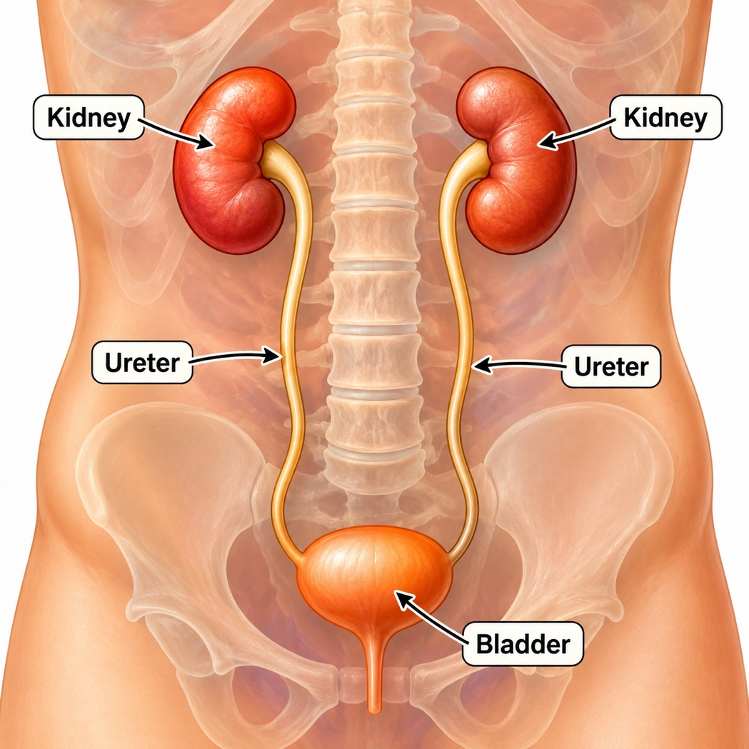

Ureter
Renal Artery and Vein
Kidney

El Sistema Urinario

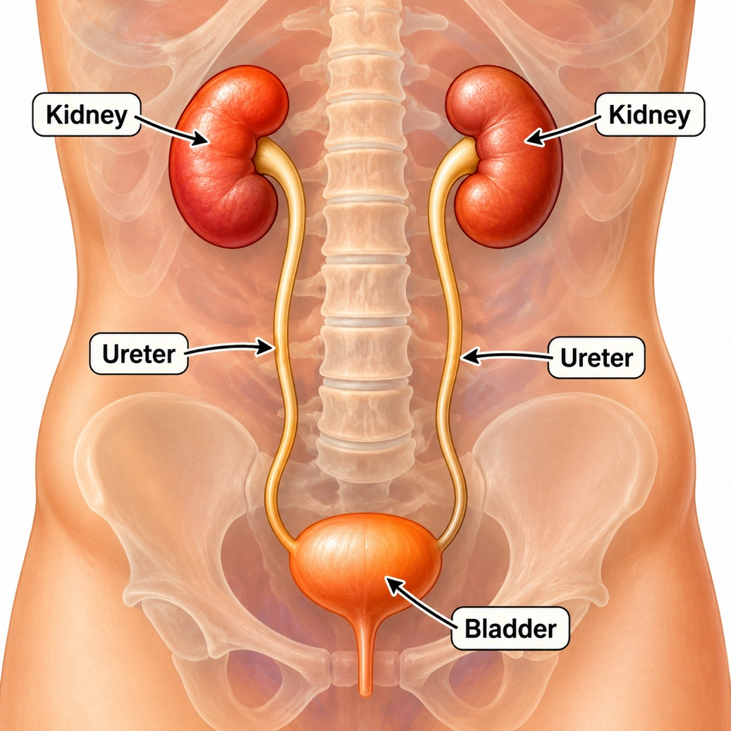
Vejiga
Uréter
Uréter
Riñon
Riñon

Arteria y Vena Renal
Uréter

Riñon

